**Indian General Election Results 2024**

1. Total Seats





1. What are the total number of Seats available for elections in each state ?

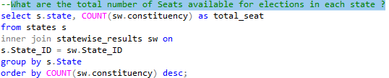

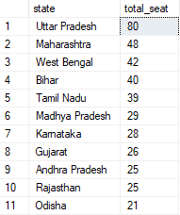

1. Total Seats Won by NDA Allianz?

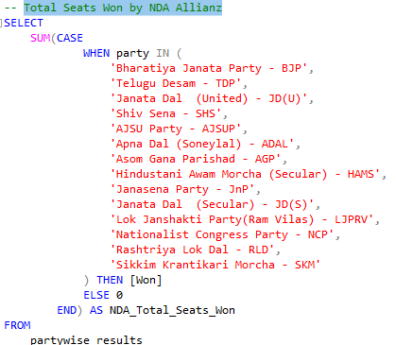



1. Seats Won by NDA Allianz Parties?

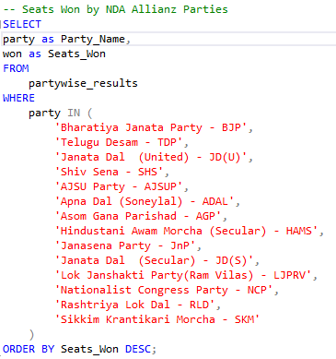

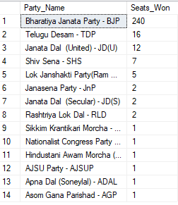

1. -- Total Seats Won by I.N.D.I.A. Allianz

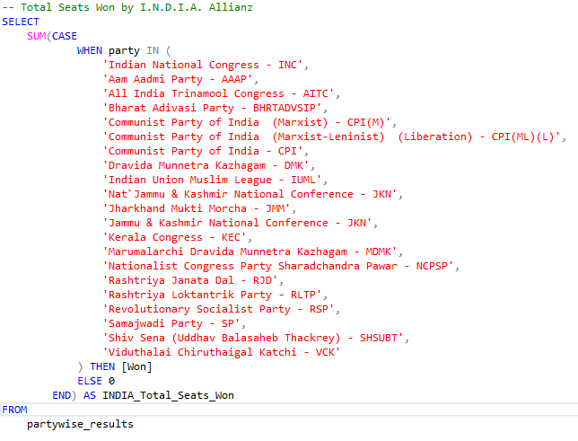



1. -- Seats Won by I.N.D.I.A. Allianz Parties

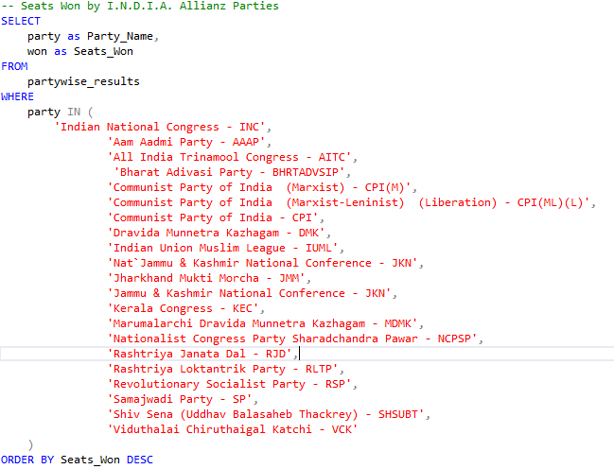

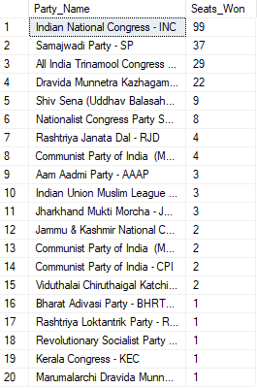

1. Add new column field in table partywise_results to get the Party Allianz as NDA, I.N.D.I.A and OTHER?





1. -- I.N.D.I.A Allianz

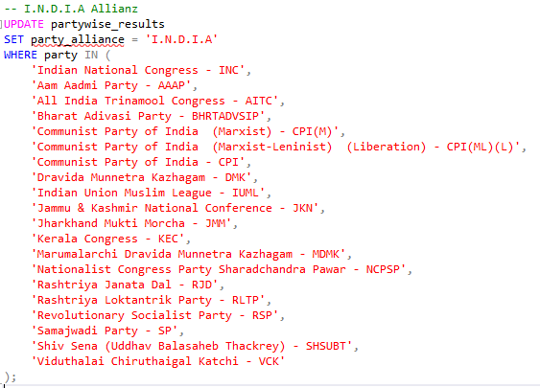

1. NDA Allianz

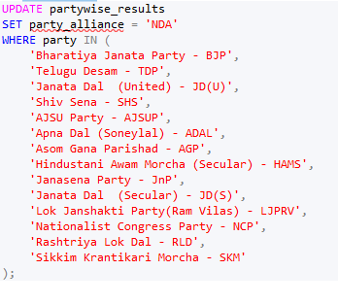

1. **OTHER**

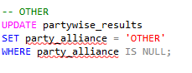

1. **Which party alliance (NDA, I.N.D.I.A, or OTHER) won the most seats across all states?**

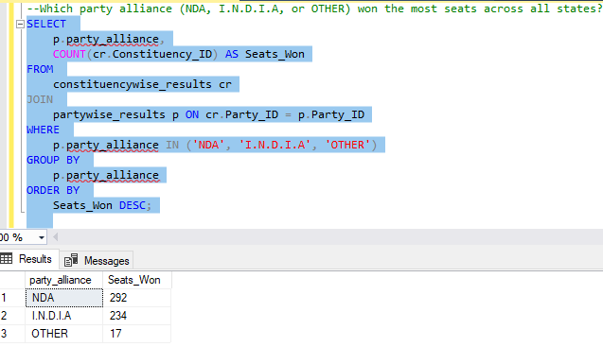

1. Winning candidate's name, their party name, total votes, and the margin of victory for a specific state and constituency?

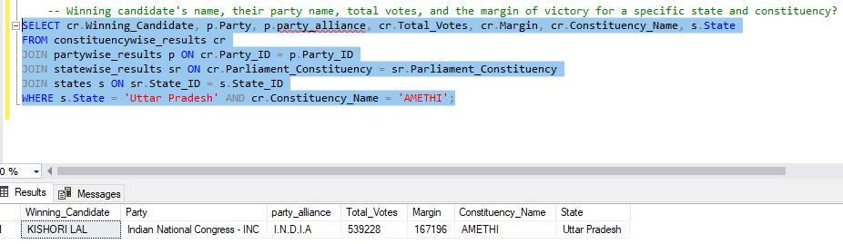

1. --What is the distribution of EVM votes versus postal votes for candidates in a specific constituency?

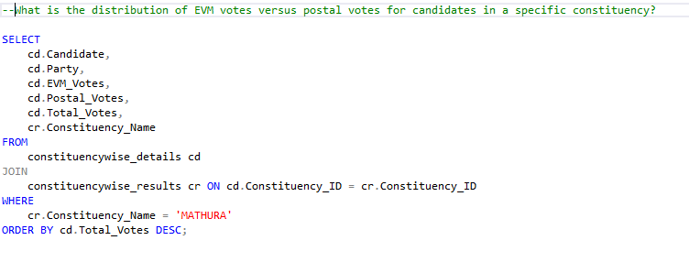

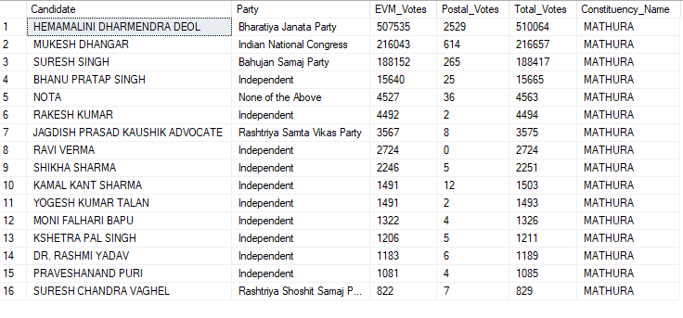

1. --Which parties won the most seats in s State, and how many seats did each party win?

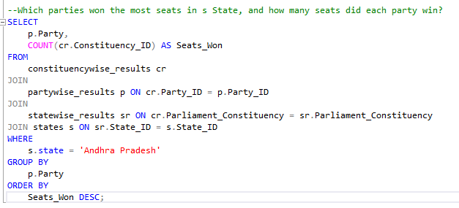

1. **What is the total number of seats won by each party alliance (NDA, I.N.D.I.A, and OTHER) in each state for the India Elections 2024**

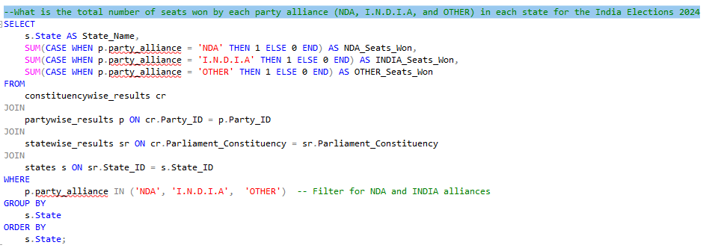

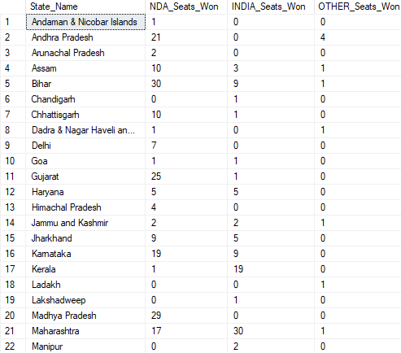

1. Which candidate received the highest number of EVM votes in each constituency (Top 10)?

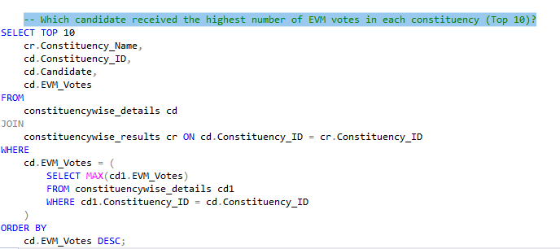

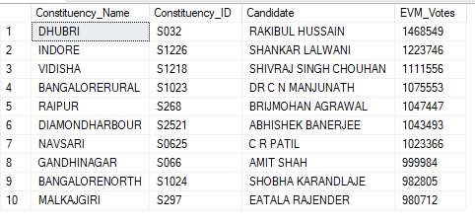

1. -- Which candidate won and which candidate was the runner-up in each constituency of State for the 2024 elections?

